| Description: Image result **Datta Meghe College of Engineering**  **Airoli, Navi Mumbai** | **DEPARTMENT OF COMPUTER ENGINEERING**  **ACADEMIC YEAR : 2025 – 26 (TERM – I)** |
| --- | --- |
| **List of Experiments**  **Course Name : Computer Network Lab**  **Course Code : CSL502** |

| **Sr. No** | **Name of experiment** | **Cos Covered** | **Page No.** | **Date of  Performance** | **Date of Submission** | **Marks & Signature** |
| --- | --- | --- | --- | --- | --- | --- |
| 1 | Use of Crimping Tool for RJ45. | CO1 |  |  |  |  |
| 2 | Use of basic networking Commands in Linux. | CO1 |  |  |  |  |
| 3 | Perform network discovery using discovery tools ( eg. Nmap, mrtg ) | CO2, CO3 |  |  |  |  |
| 4 | WAP to implement Socket Programming using TCP & UDP. | CO5 |  |  |  |  |
| 5 | Perform File Transfer and Access using FTP. | CO6 |  |  |  |  |
| 6 | Install and use Telnet in Ubuntu. | CO6 |  |  |  |  |
| 7 | Build simple Topology. | CO1 |  |  |  |  |
| 8 | Study and installation of Network Simulator. | CO1 |  |  |  |  |
| 9 | Use Wireshark to understand the operation of TCPIP layers. | CO4,  CO5 |  |  |  |  |
| 10 | Setup multiple addresses on a single LAN. | CO2 |  |  |  |  |
|  | Assignment 1 | CO1,CO2 |  |  |  |  |
|  | Assignment 2 | CO3,CO4,CO5 & CO6 |  |  |  |  |

This is to certify that Mr. / Miss ___________________________________________________ of __________________ Roll No. __________ has performed the Experiments / Assignments / Tutorials / Case Study Work mentioned above in the premises of the institution.

| ________________________ |
| --- |
| **Practical In charge** |

| **Description: Image result** | **DATTA MEGHE COLLEGE OF ENGINEERING, AIROLI, NAVI MUMBAI** | | |
| --- | --- | --- | --- |
| **DEPARTMENT OF COMPUTER ENGINEERING** | | |
| **Institute Vision** | | **:** | To create value - based technocrats to fit in the world of work and research |
| **Institute Mission** | | **:** | * To adapt the best engineering practices * To empower students to work in the world of technology and research * To create competent human beings |
| **Department Vision** | | **:** | To provide an intellectually stimulating environment for education, technological excellence in computer engineering field and professional training along with human values. |

**Department Mission :**

| **M1:** | To promote an educational environment that combines academics with intellectual curiosity. |
| --- | --- |
| **M2:** | To develop human resource with sound knowledge of theory and practical in the discipline of Computer Engineering and the ability to apply the knowledge to the benefit of society at large. |
| **M3:** | To assimilate creative research and new technologies in order to facilitate students to be a lifelong learner who will contribute positively to the economic well-being of the nation. |

**Program Educational Objectives** (**PEO):**

| **PEO1:** | To explicate optimal solutions through application of innovative computer science techniques that aid towards betterment of society. |
| --- | --- |
| **PEO2:** | To adapt recent emerging technologies for enhancing their career opportunity prospects. |
| **PEO3:** | To effectively communicate and collaborate as a member or leader in a team to manage multidisciplinary projects |
| **PEO4:** | To prepare graduates to involve in research, higher studies or to become entrepreneurs in long run. |

**Program Specific Outcomes (PSO):**

| **PSO1:** | To apply basic and advanced computational and logical skills to provide solutions to computer engineering problems |
| --- | --- |
| **PSO2:** | Ability to apply standard practices and strategies in design and development of software and hardware based systems and adapt to evolutionary changes in computing to meet the challenges of the future. |
| **PSO3:** | To develop an approach for lifelong learning and utilize multi-disciplinary knowledge required for satisfying industry or global requirements. |

**Program Outcomes as defined by NBA (PO)**

**Engineering Graduates will be able to:**

1. **Engineering knowledge**: Apply the knowledge of mathematics, science, engineering fundamentals, and an engineering specialization to the solution of complex engineering problems.

2. **Problem analysis**: Identify, formulate, review research literature, and analyze complex engineering problems reaching substantiated conclusions using first principles of mathematics, natural sciences, and engineering sciences.

3. **Design/development of solutions**: Design solutions for complex engineering problems and design system components or processes that meet the specified needs with appropriate consideration for the public health and safety, and the cultural, societal, and environmental considerations.

4. **Conduct investigations of complex problems**: Use research-based knowledge and research methods including design of experiments, analysis and interpretation of data, and synthesis of the information to provide valid conclusions.

5. **Modern tool usage**: Create, select, and apply appropriate techniques, resources, and modern engineering and IT tools including prediction and modelling to complex engineering activities with an understanding of the limitations.

6. **The engineer and society**: Apply reasoning informed by the contextual knowledge to assess societal, health, safety, legal and cultural issues and the consequent responsibilities relevant to the professional engineering practice.

7. **Environment and sustainability**: Understand the impact of the professional engineering solutions in societal and environmental contexts, and demonstrate the knowledge of, and need for sustainable development.

8. **Ethics**: Apply ethical principles and commit to professional ethics and responsibilities and norms of the engineering practice.

9. **Individual and team work**: Function effectively as an individual, and as a member or leader in diverse teams, and in multidisciplinary settings.

10. **Communication**: Communicate effectively on complex engineering activities with the engineering community and with society at large, such as, being able to comprehend and write effective reports and design documentation, make effective presentations, and give and receive clear instructions.

11. **Project management and finance**: Demonstrate knowledge and understanding of the engineering and management principles and apply these to one’s own work, as a member and leader in a team, to manage projects and in multidisciplinary environments.

**12. Life-long learning**: Recognize the need for, and have the preparation and ability to engage in independent and life-long learning in the broadest context of technological change.

**DATTA MEGHE COLLEGE OF ENGINEERING**

**Department of Computer Engineering**

**Course Name: Computer Network Lab (R-19)**

**Course Code: CSC503/CSL502**

**Year of Study: T.E., Semester: V**

**Course Outcomes**

| CSC503.1 | Demonstrate the concepts of data communication at physical layer and compare ISO - OSI model with TCP/IP model. |
| --- | --- |
| CSC 503.2 | Demonstrate the knowledge of networking protocols at data link layer. |
| CSC 503.3 | Design the network using IP addressing and subnetting / supernetting schemes. |
| CSC 503.4 | Analyze various routing algorithms and protocols at network layer. |
| CSC 503.5 | Analyze transport layer protocols and congestion control algorithms. |
| CSC 503.6 | Explore protocols at application layer . |

**DATTA MEGHE COLLEGE OF ENGINEERING**

**DEPARTMENT OF COMPUTER ENGINEERING**

**ACADEMIC YEAR 2024-25 (TERM I)**

**SUBJECT: COMPUTER NETWORK**

**SEM: V**

**RUBRICS FOR GRADING EXPERIMENTS**

| **Rubric Number** | **Rubric Title** | **Criteria** | **Marks**  **(out of 15)** |
| --- | --- | --- | --- |
| R1 | Punctuality, Completion Time / Timeline | On-time | 3 |
| Delayed by a Week | 2 |
| Delayed more than a Week | 1 |
| R2 | Knowledge & Concept | Clear understanding | 3 |
| Partially understood | 2 |
| Weak understanding | 1 |
| R3 | Implementation | Correct Implementation | 3 |
| Partial Implementation | 2 |
| Implementation with error | 1 |
| R4 | Results | Correct Results | 3 |
| Partial Results | 2 |
| Results with error | 1 |
| R5 | Documentation | Correct Documentation | 3 |
| Moderate documented | 2 |
| Not properly organized | 1 |

**DATTA MEGHE COLLEGE OF ENGINEERING**

**DEPARTMENT OF COMPUTER ENGINEERING**

**ACADEMIC YEAR 2022-23 (TERM I)**

**SUBJECT: Computer Network**

**SEM: V**

**RUBRICS FOR GRADING ASSIGNMENTS**

| **Rubric Number** | **Rubric Title** | **Criteria** | **Marks**  **(out of 5)** |
| --- | --- | --- | --- |
| **R1** | **Punctuality, Completion Time / Timeline** | **On-time** | **2** |
| **Delayed by a Week** | **1** |
| **Delayed more than a Week** | **0** |
| **R2** | **Knowledge & Concept** | **Clear understanding** | **2** |
| **Partially understood** | **1** |
| **Weak understanding** | **0** |
| **R3** | **Documentation** | **Correct Documentation** | **1** |
| **Not documented properly** | **0** |

**EXPERIMENT NO: 1**

| **Date of Performance :** |  |
| --- | --- |
| **Date of Submission :** |  |

**AIM:** Use of Crimping Tool for RJ45.

# **THEORY:**

Crimping an RJ45 Connector Correctly Proper Wiring for Ethernet Cat5/Cat5e/Cat 6 Cables

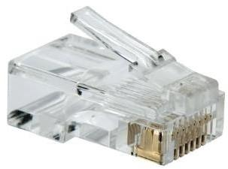

Cables can transmit information along their length. To actually get that information where it needs to go, you need to make the right connections to an RJ45 connector.

Your cable run needs to terminate into a connector, and that connector needs a jack to plug into.

Registered Jack 45 (RJ45) is a standard type of physical connector for network cables. RJ45 connectors are commonly seen with Ethernet cables and networks.

Modern Ethernet cables feature a small plastic plug on each end of the cable. That plug is inserted into RJ45 jacks of Ethernet devices. The term “plug” refers to the cable or “male” end of the connection while the term “jack” refers to the port or “female” end.

T568A or T568B Wiring Standard:

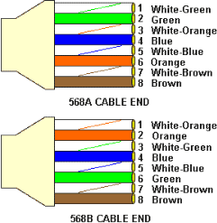

T568A and T568B are the two colour codes used for wiring eight-position modular plugs. Both are allowed under the ANSI/TIA/EIA wiring standards. The only difference between the two color codes is that the orange and green pairs are interchanged.

There is no transmission differences between T568A and T568B cabling schemes. North America’s preference is for T568B. Both ends must use the same standard. It makes no difference to the transmission characteristics of data.

**T568B** wiring pattern is recognized as the preferred wiring pattern.

| **STEP 1:**  Using a [Crimping Tool](https://www.cableorganizer.com/crimp-tools/phone-ethernet-crimp-tools.html), trim the end of the cable you're terminating, to ensure that the ends of the conducting wires are even.  Description: C:\Users\UCoE\Pictures\sscsa.PNG |
| --- |
| **STEP 2:**  Being careful not to damage the inner conducting wires, strip off approximately 1 inch of the cable's jacket, using a [modular crimping tool](https://www.cableorganizer.com/network-installation/) or a [UTP cable stripper](https://www.cableorganizer.com/network-installation/). |
| Description: C:\Users\UCoE\Pictures\dvzdvz.PNG |
| **STEP 3:**  Separate the 4 twisted wire pairs from each other, and then unwind each pair, so that you end up with 8 individual wires. Flatten the wires out as much as possible, since they'll need to be very straight for proper insertion into the connector.  Description: C:\Users\UCoE\Pictures\xxs.PNG |

| **STEP 4:**  Holding the cable with the wire ends facing away from you. Moving from left to right, arrange the wires in a flat, side-by-side ribbon formation, placing them in the following order: white/orange, solid orange, white/green, solid blue, white/blue, solid green, white/brown, solid brown. |
| --- |
|  |
| **STEP 5:**  Holding the RJ45 connector so that its pins are facing away from you and the plug-clip side is facing down, carefully insert the flattened, arranged wires into the connector, pushing through u  ntil the wire ends emerge from the pins. For strength of connection, also push as much of the cable jacket as possible into the connector.  Description: C:\Users\UCoE\Pictures\DDSDS.PNG |
| **STEP 6:**  Check to make sure that the wire ends coming out of the connector's pin side are in the correct order; if not, remove them from the connector, rearrange into proper formation, and re-insert. Remember, once the connector is crimped onto the cable, it's permanent. If you realize that a mistake has been made in wire order after termination, you'll have to cut the connector off and start all over again!  Description: C:\Users\UCoE\Pictures\scsccs.PNG |
| **STEP 7:** |

| Insert the prepared connector/cable assembly into the RJ45 slot in [your crimping tool](https://www.cableorganizer.com/crimp-tools/phone-ethernet-crimp-tools.html). Firmly squeeze the crimper's handles together until you can't go any further. Release the handles and repeat this step to ensure a proper crimp.  Description: C:\Users\UCoE\Pictures\zczAC.PNG |
| --- |
| **STEP 8:**  If your crimper doesn't automatically trim the wire ends upon termination, carefully cut wire ends to make them as flush with the connector's surface as possible. The closer the wire ends are trimmed, the better your final plug-in connection will be.  Description: C:\Users\UCoE\Pictures\SASASAC.PNG |
| **STEP 9:**  After the first termination is complete, repeat process on the opposite end of your cable  Description: C:\Users\UCoE\Pictures\ASSAS.PNG |

**CONCLUSION:** Thus, we have studied the use of crimping tool for RJ-45.

**DATE**

| **R1**  **(3 Marks)** | **R2**  **(3 Marks)** | **R3**  **(3 Marks)** | **R4**  **(3 Mark)** | **R5**  **(3 Mark)** | **Total**  **(15 Marks)** | **Signature** |
| --- | --- | --- | --- | --- | --- | --- |
|  |  |  |  |  |  |  |

**EXPERIMENT No. 2**

| **Date of Performance :** |  |
| --- | --- |
| **Date of Submission :** |  |

**AIM:** Use basic networking commands in Linux (ping, tracert, nslookup, netstat, ARP, RARP, ip, ifconfig, dig, route )

**THEORY:**

1. **ifconfig**

**ifconfig**(interface configuration) command is used to configure the kernel-resident network interfaces. It is used at the boot time to set up the interfaces as necessary. After that, it is usually used when needed during debugging or when you need system tuning. Also, this command is used to assign the IP address and netmask to an interface or to enable or disable a given interface.

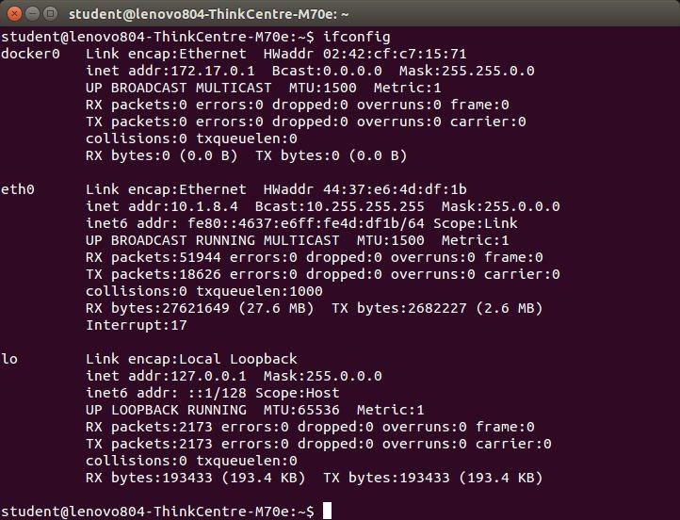

1. **NSLOOKUP**

**Nslookup**(stands for “Name Server Lookup”) is a useful command for getting information from DNS server. It is a network administration tool for querying the Domain Name System (DNS) to obtain domain name or IP address mapping or any other specific DNS record. It is also used to troubleshoot DNS related problems.

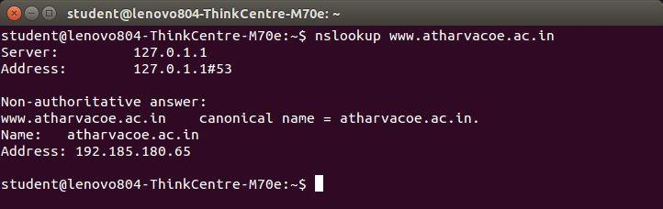

1. **Ping**

# PING (Packet Internet Groper) command is used to check the network connectivity between host and server/host. This command takes as input the IP address or the URL and sends a data packet to the specified address with the message “PING” and get a response from the server/host this time is recorded which is called latency. Fast ping low latency means faster connection. Ping uses [**ICMP(Internet Control Message Protocol)**](https://www.geeksforgeeks.org/internet-control-message-protocol-icmp/) to send an **ICMP echo message** to the specified host if that host is available then it sends **ICMP reply message**. Ping is generally measured in millisecond every modern operating system has this ping pre-installed.

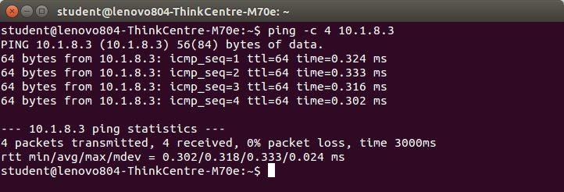

1. **TRACEROUTEac**

**traceroute** command in Linux prints the route that a packet takes to reach the host. This command is useful when you want to know about the route and about all the hops that a packet takes. Below image depicts how traceroute command is used to reach the Google(172.217.26.206) host from the local machine and it also prints detail about all the hops that it visits in between.

c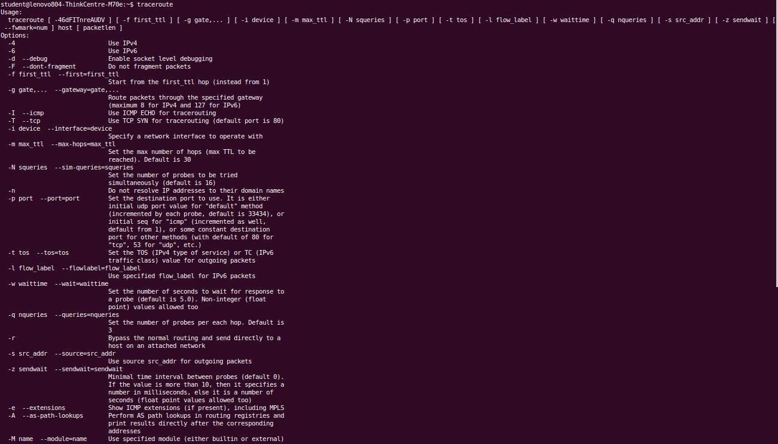

1. **Netstat**

Netstat command displays various network related information such as network connections, routing tables, interface statistics, masquerade connections, multicast memberships etc.

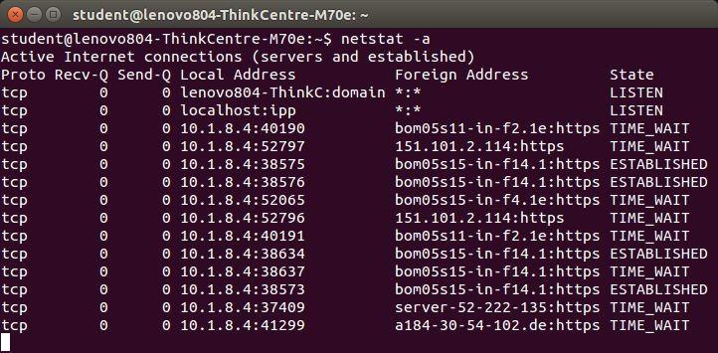

1. **ARP**

**arp command** manipulates the System’s ARP cache. It also allows a complete dump of the ARP cache. ARP stands for Address Resolution Protocol. The primary function of this protocol is to resolve the IP address of a system to its mac address, and hence it works between level 2(Data link layer) and level 3(Network layer).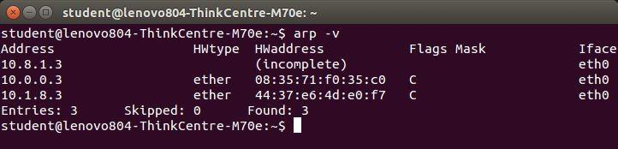

1. **IP**

**ip** command in Linux is present in the net-tools which is used for performing several network administration tasks. IP stands for Internet Protocol. This command is used to show or manipulate routing, devices, and tunnels. It is similar to [*ifconfig*](https://www.geeksforgeeks.org/ifconfig-command-in-linux-with-examples/) command but it is much more powerful with more functions and facilities attached to it. *ifconfig* is one of the deprecated commands in the net-tools of Linux that has not been maintained for many years. ip command is used to perform several tasks like assigning an address to a network interface or configuring network interface parameters.  
It can perform several other tasks like configuring and modifying the default and static routing, setting up tunnel over IP, listing IP addresses and property information, modifying the status of the interface, assigning, deleting and setting up IP addresses and routes.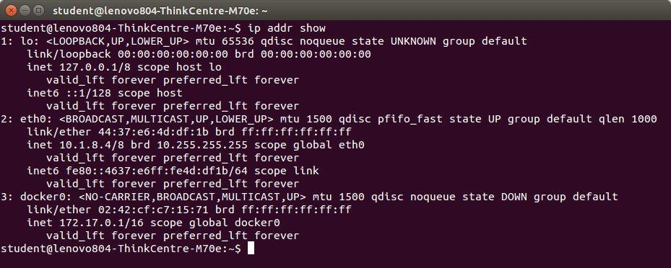

1. **Dig**

**dig** command stands for ***Domain Information Groper***. It is used for retrieving information about DNS name servers. It is basically used by network administrators. It is used for verifying and troubleshooting DNS problems and to perform DNS lookups. Dig command replaces older tools such as [nslooku](https://www.geeksforgeeks.org/nslookup-command-in-linux-with-examples/)p and the [host](https://www.geeksforgeeks.org/host-command-in-linux-with-examples/).

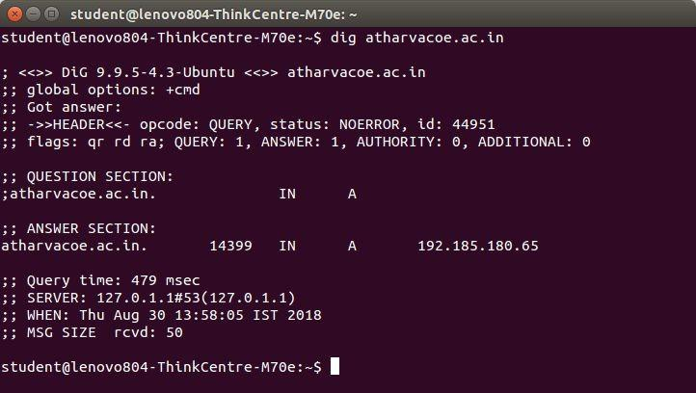

**CONCLUSION:** Hence, in this experiment, we have successfully studied some important networking command and also implemented them in Linux

**SIGN AND REMARK**

**DATE**

| **R1**  **(3 Marks)** | **R2**  **(3 Marks)** | **R3**  **(3 Marks)** | **R4**  **(3 Mark)** | **R5**  **(3 Mark)** | **Total**  **(15 Marks)** | **Signature** |
| --- | --- | --- | --- | --- | --- | --- |
|  |  |  |  |  |  |  |

**EXPERIMENT No. 3**

| **Date of Performance :** |  |
| --- | --- |
| **Date of Submission :** |  |

**AIM:** Perform network discovery using discovery tools (eg. Nmap, mrtg)

Nmap (Network Mapper) is a security scanner originally written by Gordon Lyon (also known by his pseudonym Fyodor Vaskovich) used to discover hosts and services on a computer network, thus creating a "map" of the network. To accomplish its goal, Nmap sends specially crafted packets to the target host and then analyzes the responses. Unlike many simple port scanners that just send packets at some predefined constant rate, Nmap accounts for the network conditions (latency fluctuations, network congestion, the target interference with the scan) during the run. Also, owing to the large and active user community providing feedback and contributing to its features, Nmap has been able to extend its discovery capabilities beyond simply figuring out whether a host is up or down and which ports are open and closed; it can determine the operating system of the target, names and versions of the listening services, estimated uptime, type of device, and presence of a firewall.

### **Nmap features include:**

* Host Discovery – Identifying hosts on a network. For example, listing the hosts which respond to pings or have a particular port open.
* Port Scanning – Enumerating the open ports on one or more target hosts.
* Version Detection – Interrogating listening network services listening on remote devices to determine the application name and version number.
* OS Detection – Remotely determining the operating system and some hardware characteristics of network devices.

### **Basic commands working in Nmap:**

* For target specifications: nmap <target‘s URL or IP with spaces between them>
* For OS detection: nmap -O <target-host's URL or IP>
* For version detection: nmap -sV <target-host's URL or IP>

SYN scan is the default and most popular scan option for good reasons. It can be performed quickly, scanning thousands of ports per second on a fast network not hampered by restrictive firewalls. It is also relatively unobtrusive and stealthy since it never completes TCP connections

### **Algorithm\Implementation Steps\Installation Steps:**

1. Download Nmap from [www.nmap.org](http://www.nmap.org/) and install the Nmap Software with WinPcap Driver utility.
2. Execute the Nmap-Zenmap GUI tool from Program Menu or Desktop Icon
3. Type the Target Machine IP Address(ie.Guest OS or any website Address)
4. Perform the profiles shown in the utility.



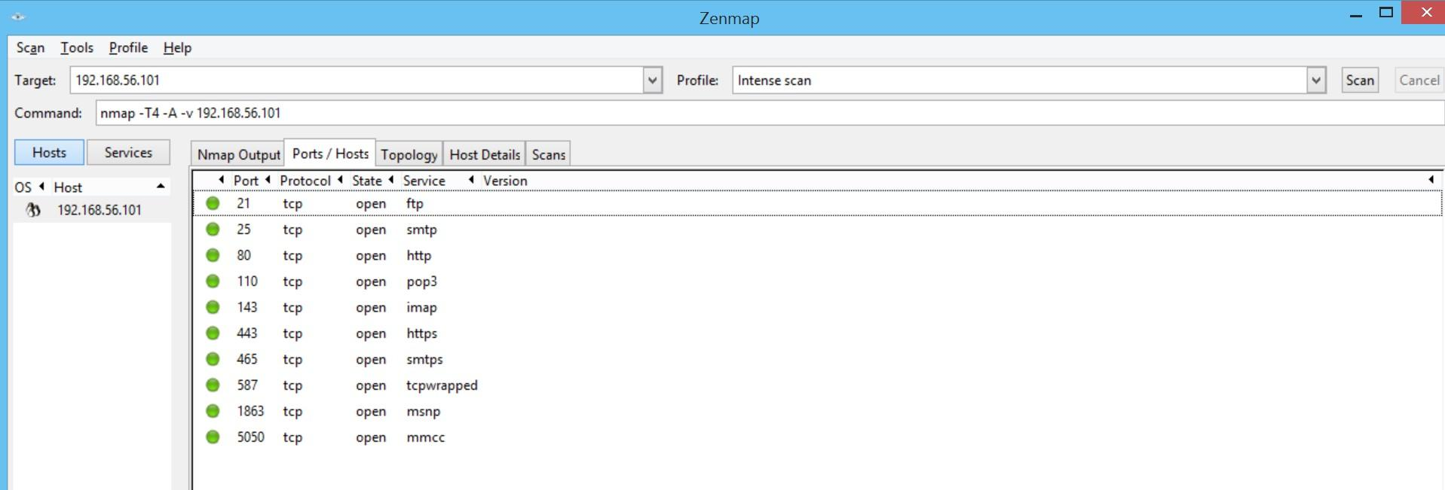



**CONCLUSION:** Thus, we have studied different options to scan ports in Nmap

**SIGN AND REMARK**

**DATE**

| **R1**  **(3 Marks)** | **R2**  **(3 Marks)** | **R3**  **(3 Marks)** | **R4**  **(3 Mark)** | **R5**  **(3 Mark)** | **Total**  **(15 Marks)** | **Signature** |
| --- | --- | --- | --- | --- | --- | --- |
|  |  |  |  |  |  |  |

**EXPERIMENT No. 4**

| **Date of Performance :** |  |
| --- | --- |
| **Date of Submission :** |  |

**Aim:**WAP to implement Socket Programming using TCP & UDP

# **Theory:**

**Socket** : the communication object.

A socket connection is a 4-tuple -- (HostA, PortA, HostB, PortB) -- uniquely defining the connection.

## ***Transmission Control Protocol (TCP)***

TCP provides a *connection oriented service*, since it is based on connections between clients and servers.

TCP provides reliability. When a TCP client send data to the server, it requires an acknowledgement in return. If an acknowledgement is not received, TCP automatically retransmit the data and waits for a longer period of time.

**TCP properties:** reliable, connection-oriented, byte-stream, connection established before application-level protocols exchange information, two-way communication

**The client-server model:**The client-server model is one of the most used communication paradigms in networked systems. Clients normally communicates with one server at a time. From a server’s perspective, at any point in time, it is not unusual for a server to be communicating with multiple clients. Client need to know of the existence of and the address of the server, but the server does not need to know the address of (or even the existence of) the client prior to the connection being established

## ***TCP Socket API***

The sequence of function calls for the client and a server participating in a TCP connection is presented in below..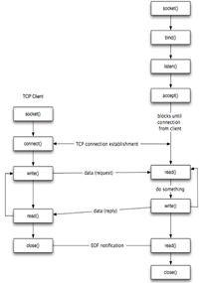

Fig: TCP Client Server

As shown in the figure, the steps for establishing a TCP socket on the client side are the following:

* Create a socket using the socket() function;
* Connect the socket to the address of the server using the connect() function;
* Send and receive data by means of the read() and write() functions.

The steps involved in establishing a TCP socket on the server side are as follows:

* Create a socket with the socket() function;
* Bind the socket to an address using the bind() function;
* Listen for connections with the listen() function;
* Accept a connection with the accept() function system call. This call typically blocks until a client connects with the server.
* Send and receive data by means of send() and receive().

**B) WAP to implement socket programming using UDP. Theory:**

Datagram sockets, also known as connectionless sockets, which use User Datagram Protocol (UDP). Stream sockets, also known as connection-oriented sockets, which use Transmission Control Protocol (TCP), Stream Control Transmission Protocol (SCTP) or Datagram Congestion Control Protocol (DCCP).

**UDP propert**ies: unreliable, packet-switched, packet data, no connection overhead, application-level protocols exchange information immediately, two-way communication.

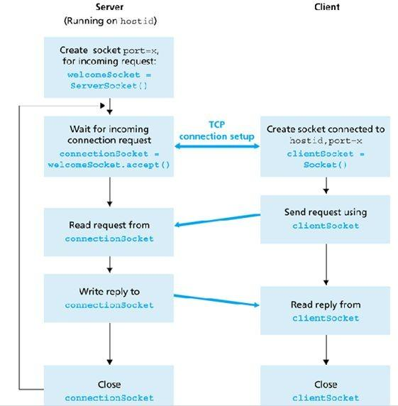

Fig. TCP/IP client/server communication flow



Fig: UDP client/server communication flow:

**TCP/IP Vs UDP** :

1. Connection oriented (bidirectional communication sockets which keeps track of connection state, established connection , and also create reciever buffer on both sides of the end to end connection) & other is Connection less (does not keep track of the connection state and it does not have reciver buffer on either side sender or reciver)
2. Will have Acknowledgment & other one don't
3. Performance slow & other one fast
4. More secure & other is not much
5. TCP/IP offer guaranteed delivery while UDP does not
6. TCP/IP consumes high bandwidth. UDP is good guy and shares band with everyone.
7. TCP/IP guarantees sequencing of packets (Packet sent first will reach destination first). In UDP you may get last packet first or not at all.
8. TCP does not have message block boundaries (User has to define its own)
9. TCP can Transmit large amount of data as compared to udp
10. Sequencing of packet is guranted in TCP.Means the packets that are sent is delivered in time where in UDP it is not guranted that the packets will reach in time to the destination.

## ***Code:***

**A] TCP**

**Server Side:**

import java.net.*;

import java.io.*;

class ServerSide

{

public static void main(String[] args) throws Exception

{

int choice,a,b,c=0;

ServerSocket ss = new ServerSocket(1024);

Socket s = ss.accept();

BufferedReader br = new BufferedReader(new InputStreamReader (s.getInputStream() ) );

choice =Integer.parseInt(br.readLine());

a =Integer.parseInt(br.readLine());

b = Integer.parseInt(br.readLine());

switch(choice)

{

case 1 : c = a+b; break;

case 2 : c = a-b; break;

case 3 : c = a*b; break;

case 4 : c = a/b; break;

case 5 : c = (a%b); break;

}

PrintStream pr = new PrintStream(s.getOutputStream()) ;

pr.println(c);

ss.close();

s.close();

}

}

**Client Side:**

import java.net.*;

import java.io.*;

class ClientSide

{

public static void main(String[] args) throws Exception

{

int ch=0,a,b,c;

Socket s = new Socket("localhost",1024); BufferedReader br =

newBufferedReader(newInputStreamReader(System.in));

PrintStream ps=new PrintStream(s.getOutputStream()); System.out.println("Please Enter Number 1:");

a = Integer.parseInt(br.readLine());

System.out.println("Please Enter Number 2:"); b = Integer.parseInt(br.readLine());

System.out.println("Please Enter The Operation to Be

Performed\n");

System.out.println("1.Addition 2.Subtraction 3.Multiplication 4.Divison 5.Modulo 0.Exit");

ch = Integer.parseInt(br.readLine());

ps.println(ch);

ps.println(a);

ps.println(b);

BufferedReader br1 = new BufferedReader(new InputStreamReader(s.getInputStream()));

c=Integer.parseInt(br1.readLine());

System.out.println("Answer: "+c); s.close();

}

}

OUTPUT:

Server Side:

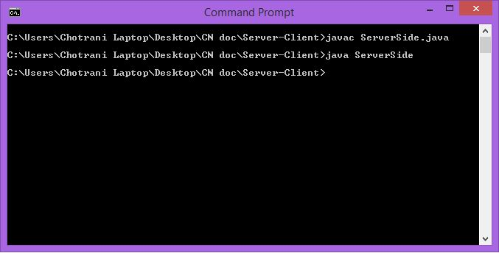

Client Side:

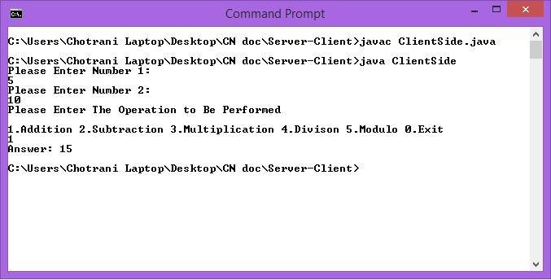

# **B] UDP**

**Server Socket Program:**

import java.io.*; import java.util.*; import java.net.*; class ServerUDP

{

public static void main(String args[])throws IOException

{

DatagramSocket ss=new DatagramSocket(2100); byte[] sendData=new byte[1024];

byte[] recData=new byte[1024]; while(true)

{

DatagramPacket dp=new DatagramPacket(recData,recData.length);

ss.receive(dp);

String input=new String(dp.getData()); if(input=="end")

break;

InetAddress ip=dp.getAddress(); System.out.println("Received input : "+input); String output="Hello ";

int port=dp.getPort(); output=output.concat(input); sendData=output.getBytes(); DatagramPacket dp1=new

DatagramPacket(sendData,sendData.length,ip,port); ss.send(dp1);

}

ss.close();

}

}

**Client Socket Program:**

import java.io.*; import java.util.*; import java.net.*; class ClientUDP

{public static void main(String args[])throws IOException

{ BufferedReader br=new BufferedReader(new InputStreamReader(System.in)); DatagramSocket ds=new DatagramSocket();

InetAddress ip=InetAddress.getByName("localhost"); byte[] sendData=new byte[1024];

byte[] recData=new byte[1024]; System.out.println("Enter your name :"); String input=br.readLine(); sendData=input.getBytes(); DatagramPacket dp=new

DatagramPacket(sendData,sendData.length,ip,2100); ds.send(dp);

DatagramPacket dp1=new DatagramPacket(recData,recData.length);

ds.receive(dp1);

String output=new String(dp1.getData()); System.out.println(output);

ds.close();

}

}

## ***OUTPUT:***

**Server Side:**

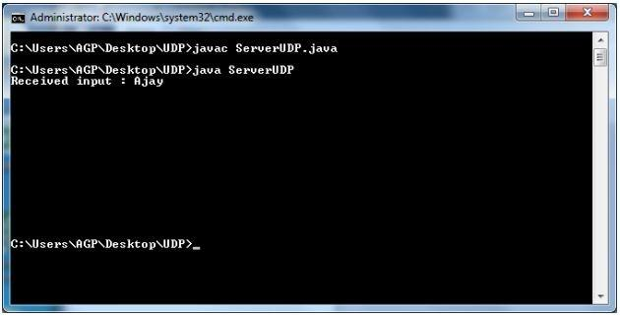

**Client Side:**

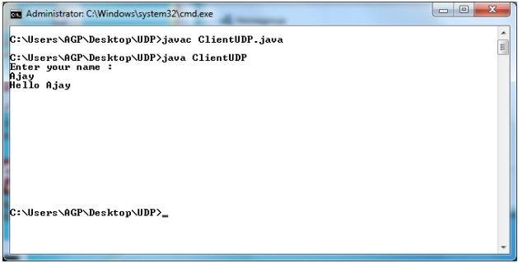

**Conclusion:** Hence we successfully studied and implemented the program of TCP and UDP.

**SIGN AND REMARK**

**DATE**

| **R1**  **(3 Marks)** | **R2**  **(3 Marks)** | **R3**  **(3 Marks)** | **R4**  **(3 Mark)** | **R5**  **(3 Mark)** | **Total**  **(15 Marks)** | **Signature** |
| --- | --- | --- | --- | --- | --- | --- |
|  |  |  |  |  |  |  |

**EXPERIMENT No. 5**

| **Date of Performance :** |  |
| --- | --- |
| **Date of Submission :** |  |

**Aim:** Perform File Transfer and Access using FTP

# **Theory:**

## ***Configuration of ftp server***

File Transfer Protocol (FTP) is a TCP protocol for uploading and downloading files between computers. FTP works on a client/server model. The server component is called an *FTP daemon*. It continuously listens for FTP requests from remote clients. When a request is received, it manages the login and sets up the connection. For the duration of the session it executes any of commands sent by the FTP client.

Access to an FTP server can be managed in two ways:

* Anonymous
* Authenticated

In the Anonymous mode, remote clients can access the FTP server by using the default user account called "anonymous" or "ftp" and sending an email address as the password.

In the Authenticated mode a user must have an account and a password. User access to the FTP server directories and files is dependent on the permissions defined for the account used at login. As a general rule, the FTP daemon will hide the root directory of the FTP server and change it to the FTP Home directory. This hides the rest of the file system from remote sessions.

## ***Steps***

1. vsftpd is an FTP daemon available in Ubuntu. To install **vsftpd** we can run the following command in root mode:
2. User authenticated FTP Configuration

To configure **vsftpd** to authenticate system users and allow them to upload files. To make a copy of the original config file, we use cp command. Configure vsftpd using gedit.

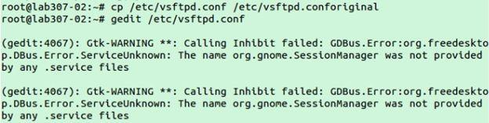

Uncomment the following lines in “vsftpd.conf” configuration file # Uncomment this to allow local users to log in. local_enable=YES

#

# Uncomment this to enable any form of FTP write command. write_enable=YES

#

1. Now restart vsftpd

To start or stop the service use command:

#service vsftpd start #service vsftpd stop

1. add new user

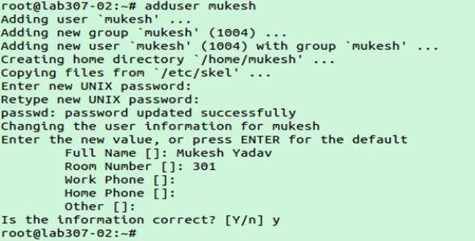

1. In your browser type: ftp://localhost and enter login username and password.

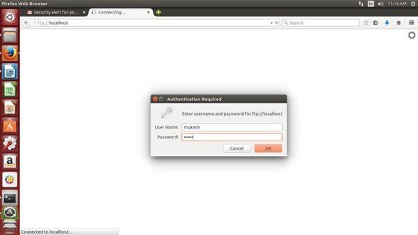

1. After authentication, we can transfer and access files using ftp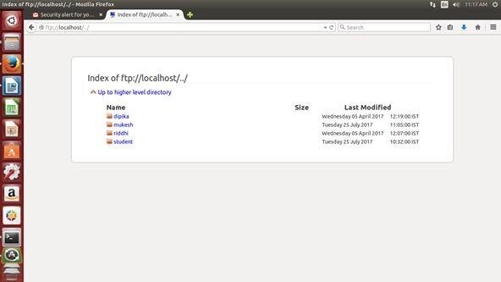

Some common ftp commands:

| ? | to request help or information about the FTP commands |
| --- | --- |
| ascii | to set the mode of file transfer to ASCII |

| binar y | to set the mode of file transfer to binary |
| --- | --- |
| bye | to exit the FTP environment (same as quit) |
| cd | to change directory on the remote machine |
| close | to terminate a connection with another computer |
| delete | to delete (remove) a file in the current remote directory (same as rm in UNIX) |
| get | to copy one file from the remote machine to the local machine  **get ABC DEF**  This copies file ABC in the current remote directory to (or on top of) a file named DEF in your current local directory.  **get ABC**  This copies file ABC in the current remote directory to (or on top of) a file with the same name, ABC, in your current local directory. |
| help | to request a list of all available FTP commands |
| lcd | to change directory on your local machine (same as UNIX cd) |
| ls | to list the names of the files in the current remote directory |
| mkdir | to make a new directory within the current remote directory |
| mget | to copy multiple files from the remote machine to the local machine;  you are prompted for a y/n answer before transferring each file  **mget \***  This copies all the files in the current remote directory to your current local directory, using the same filenames. Notice the use of the wild card character, *. |
| mput | to copy multiple files from the local machine to the remote machine;  you are prompted for a y/n answer before transferring each file |
| open | to open a connection with another computer |
| put | to copy one file from the local machine to the remote machine |

| pwd | to find out the pathname of the current directory on the remote machine |
| --- | --- |
| quit | to exit the FTP environment (same as bye) |
| rmdir | to to remove (delete) a directory in the current remote directory |

# **Output:**

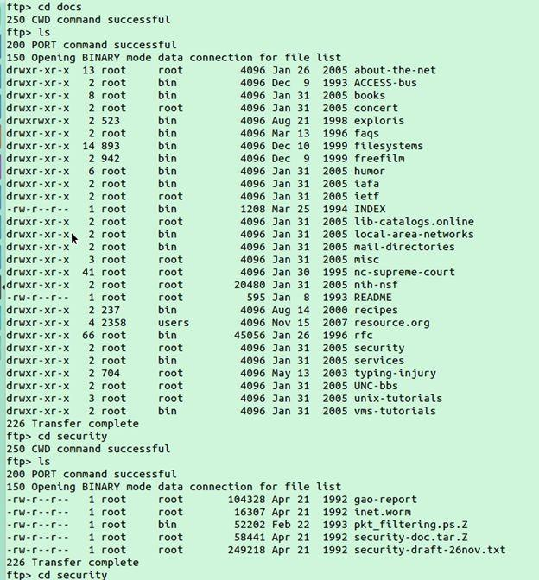

**Conclusion:** Hence we successfully studied the program of FTP.

**SIGN AND REMARK**

**DATE**

| **R1**  **(3 Marks)** | **R2**  **(3 Marks)** | **R3**  **(3 Marks)** | **R4**  **(3 Mark)** | **R5**  **(3 Mark)** | **Total**  **(15 Marks)** | **Signature** |
| --- | --- | --- | --- | --- | --- | --- |
|  |  |  |  |  |  |  |

**EXPERIMENT No. 6**

| **Date of Performance :** |  |
| --- | --- |
| **Date of Submission :** |  |

**Aim :** Install and Use Telnet in Ubuntu.

# **Theory:**

The telnet command is used for interactive communication with another host using the TELNET protocol. It begins in command mode, where it prints a telnet prompt ("telnet> "). If telnet is invoked with a host argument, it performs an open command implicitly; see the description below.

Options:

-4 Force IPv4 address resolution.

-6 Force IPv6 address resolution.

-8 Request 8-bit operation. This causes an attempt to negotiate the TELNET BINARY

option for both input and output. By default telnet is not 8-bit clean.

-E Disables the escape character functionality; that is, sets the escape character to

``no character''.

-K Specifies no automatic login to the remote system.

-L Specifies an 8-bit data path on output.This causes the TELNET BINARY option to negotiated on just output.

Once a connection has been opened, **telnet** will attempt to enable the TELNET LINEMODE option.If this fails, then **telnet** will revert to one of two input modes: either “character at a time” or “old line by line” depending on what the remote system supports

## ***Steps to Install and Use Telnet in Ubuntu:***

**Step 1:** Firstly, open the **“Terminal”** window by pressing **“Ctrl + Alt + T”**. In the figure, you may see **“$”** that signifies that you are not logged in as a root user.

So, I”ll write **“sudo apt-get install telnetd”** and press enter. If you are a root user, then you don’t need to write sudo in Ubuntu. **“telnetd”** is a daemon that gets invoked by *“inetd” or its extension “xinetd”*, both are the internet servers.

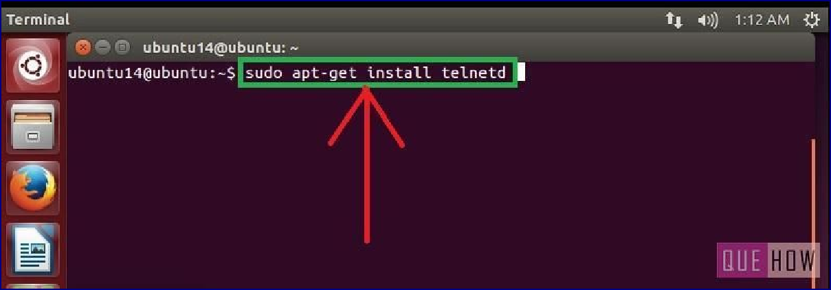

**Step 2:** Then you are asked to enter the user password and then press enter. Processing will start as soon as you press enter. After this, I have noticed a line **“274 KB additional disk space will be used”** on the terminal screen.

You may also observe some sort of a message like this and then you”ll be asked to continue or not. Just write **“y”** and then press enter to continue.

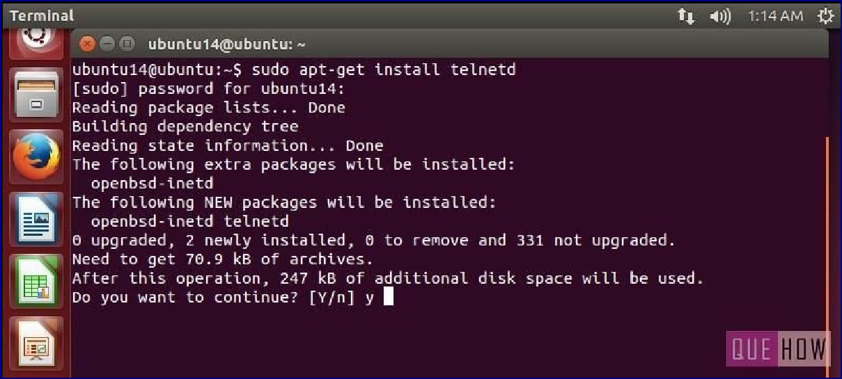

**Step 3:** Now when you are done with it, **restart “inetd”**.

Type **“sudo** /etc/init.d.open-bsd-inetd restart”.

*“inetd”* is daemon used for *dealing with incoming network* and it is responsible for deciding which program to run when a request comes.

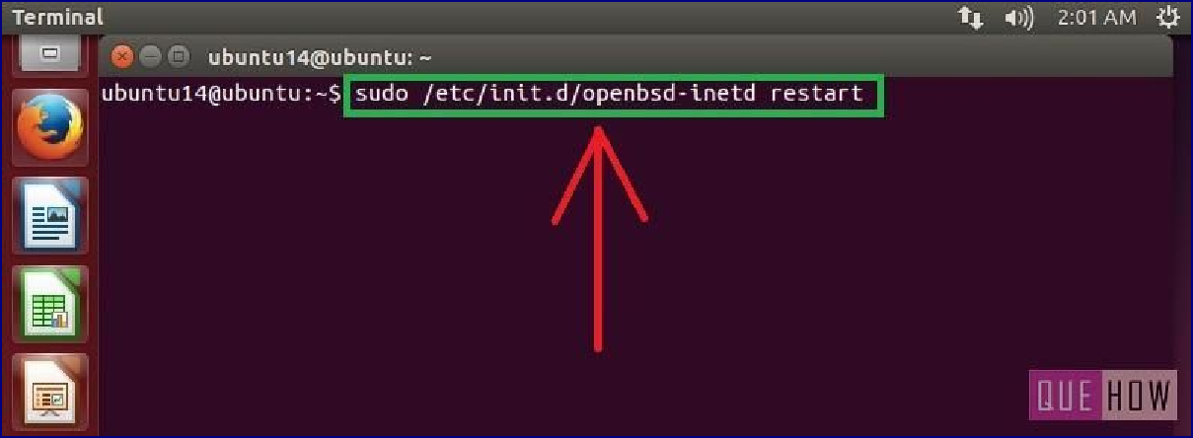

**Step 4:** To ensure “inetd” is started, press enter after writing the above command.

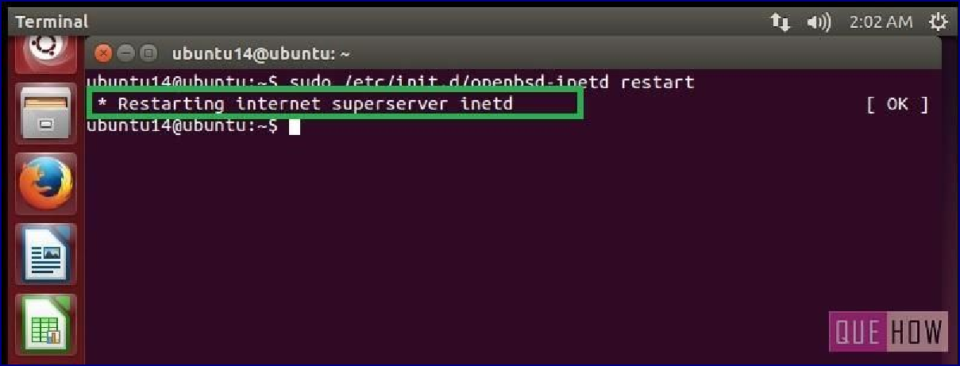

## ***To connect with any remote client:***

**Step 5:** Just type:**“telnet hostipaddress”**. For an example: “telnet 122.175.140.221” and press enter.

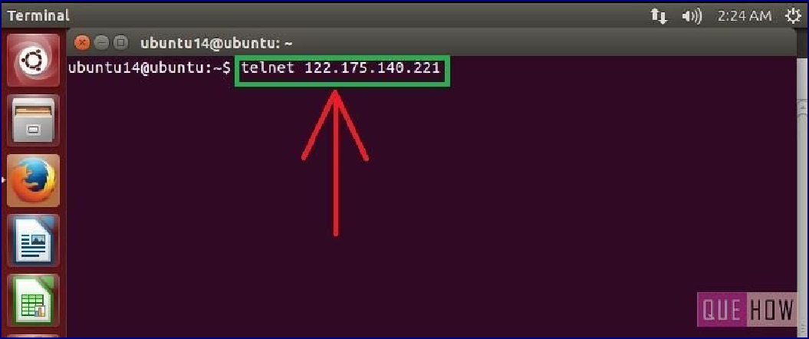

**Step 6:** Then you”ll see, it is connected to **“host ip address”**. For security reasons, you are required to provide “username” and “password” as well.

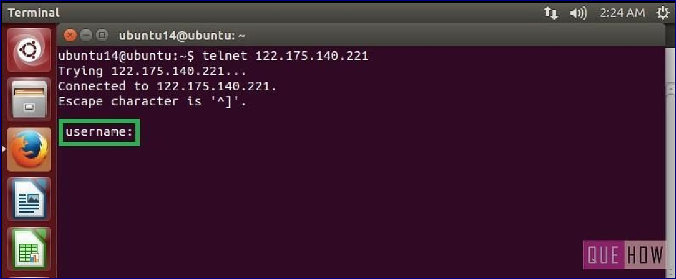

**Conclusion:** Hence we successfully studied the program of telnet.

**SIGN AND REMARK**

**DATE**

| **R1**  **(3 Marks)** | **R2**  **(3 Marks)** | **R3**  **(3 Marks)** | **R4**  **(3 Mark)** | **R5**  **(3 Mark)** | **Total**  **(15 Marks)** | **Signature** |
| --- | --- | --- | --- | --- | --- | --- |
|  |  |  |  |  |  |  |

**EXPERIMENT No. 7**

| **Date of Performance :** |  |
| --- | --- |
| **Date of Submission :** |  |

**AIM:** Build a simple network topology and configure it for static routing protocol using packet tracer. Setup a network and configure IP addressing, subnetting, masking.

**THEORY:** Cisco Packet Tracer is a [cross-platform](https://en.wikipedia.org/wiki/Cross-platform) visual [simulation](https://en.wikipedia.org/wiki/Simulation) tool designed by [Cisco](https://en.wikipedia.org/wiki/Cisco_Systems) [Systems](https://en.wikipedia.org/wiki/Cisco_Systems) that allows users to create [network topologies](https://en.wikipedia.org/wiki/Network_topologies) and imitate modern [computer networks](https://en.wikipedia.org/wiki/Computer_networks). The software allows users to simulate the configuration of Cisco routers and switches using a simulated command line interface. Packet Tracer makes use of a [drag and drop](https://en.wikipedia.org/wiki/Drag_and_drop) user interface, allowing users to add and remove simulated network devices as they see fit. The software is mainly focused towards Certified Cisco Network Associate Academy students as an educational tool for helping them learn fundamental CCNA concepts.

**Steps:**

1. Pick a total of 4 pcs in the packet tracer application. 2.We need 2 routers.

1. We need a single router.

**Connect the devices as shown below:**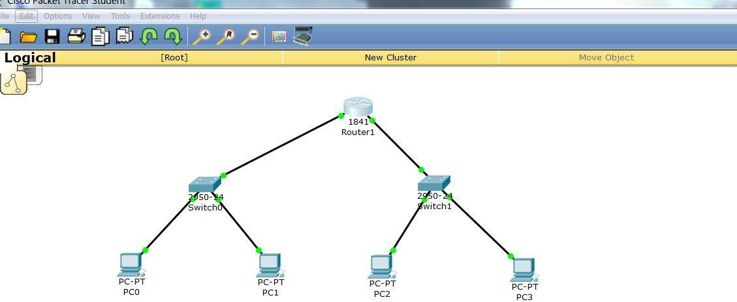

4.Give the appropriate IP addresses to the pcs accordingly.

5.Test the network with the help of packets.

**CONCLUSION:** Hence we have successfully created simple network using

**SIGN AND REMARK**

**DATE**

| **R1**  **(3 Marks)** | **R2**  **(3 Marks)** | **R3**  **(3 Marks)** | **R4**  **(3 Mark)** | **R5**  **(3 Mark)** | **Total**  **(15 Marks)** | **Signature** |
| --- | --- | --- | --- | --- | --- | --- |
|  |  |  |  |  |  |  |

**EXPERIMENT No. 8**

| **Date of Performance :** |  |
| --- | --- |
| **Date of Submission :** |  |

**AIM:**  Study and Installation of Network Simulator (NS3)

**Theory:**

The *ns-3* simulator is a discrete-event network simulator targeted primarily for research and educational use. The [**ns-3 project**](http://www.nsnam.org/), started in 2006, is an open-source project developing *ns-3*.

The purpose of this tutorial is to introduce new *ns-3* users to the system in a structured way. It is sometimes difficult for new users to glean essential information from detailed manuals and to convert this information into working simulations. In this tutorial, we will build several example simulations, introducing and explaining key concepts and features as we go.

As the tutorial unfolds, we will introduce the full *ns-3* documentation and provide pointers to source code for those interested in delving deeper into the workings of the system.

A few key points are worth noting at the onset:

* *ns-3* is open-source, and the project strives to maintain an open environment for researchers to contribute and share their software.
* *ns-3* is not a backwards-compatible extension of [**ns-2**](http://www.isi.edu/nsnam/ns); it is a new simulator. The two simulators are both written in C++ but *ns-3* is a new simulator that does not support the *ns-2* APIs.

**For the installation of NS3, VMware workstation is required to be installed, along with an Ubuntu system.**

1. Download VMWare workstation from the website: [https://my.vmware.com/en/web/vmware/downloads/info/slug/desktop_end_user_compu ting/vmware_workstation_player/15_0](https://my.vmware.com/en/web/vmware/downloads/info/slug/desktop_end_user_compu%20ting/vmware_workstation_player/15_0)

2. Download Ubuntu 20.04.01 Desktop AMD 64 from the website: <https://ubuntu.com/download/desktop>

3. Install VMWare workstation onto the computer system and open it

4. Set up the VMware workstation: a. Create a new virtual machine by selecting “Create New Virtual Machine.”

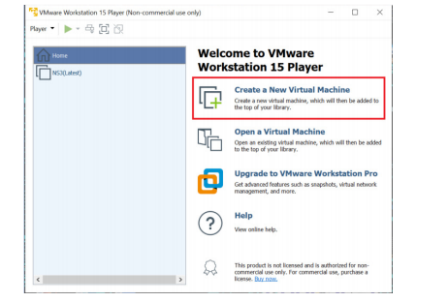

1. In the installer wizard, select installer disc image file(iso) and select the downloaded Ubuntu 20.04.01 AMD 64 iso file by browsing through the computer download files.

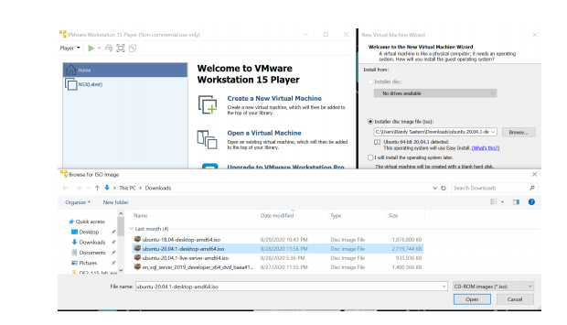

c. Name the machine and set the password.

d. Configure the Hardware:

i. For memory: set the value to 4600 MB or above.

ii. For faster VMware, set processors to 2.

5. Power on the virtual machine and let the machine update.

6. Within the Virtual machine, download NS3 on the VM by opening Mozilla firefox and downloading from the NS3 website.

7. Install prereq packages on Ubuntu using terminal:

a. Open the terminal by right clicking the desktop and select “open in terminal.”

b. Paste in this code and then press enter: sudo apt-get install g++ python3 python3-dev pkg-config sqlite3 python3- setuptools git qt5-default mercurial gir1.2-goocanvas-2.0 python-gi python-gi-cairo python3-gi python3-gi-cairo python3-pygraphviz gir1.2- gtk-3.0 ipython3 openmpi-bin openmpi-common openmpi-doc libopenmpi-dev autoconf cvs bzr unrar gdb valgrind uncrustify doxygen graphviz imagemagick texlive texlive-extra-utils texlive-latex-extra texlivefont-utils dvipng latexmk python3-sphinx dia gsl-bin libgsl-dev libgsl23 libgslcblas0 tcpdump sqlite sqlite3 libsqlite3-dev libxml2 libxml2-dev cmake libc6-dev libc6-dev-i386 libclang-6.0-dev llvm-6.0-dev automake python3-pip libgtk-3-dev synaptic vtun lxc uml-utilities

c. After the packages have finished downloading, paste in this code and press enter: sudo pip3 install cxxfilt

8. After installing the required packages, create a folder named workspace in the home directory and then put the NS3 tar package into the workspace. See example figure below.

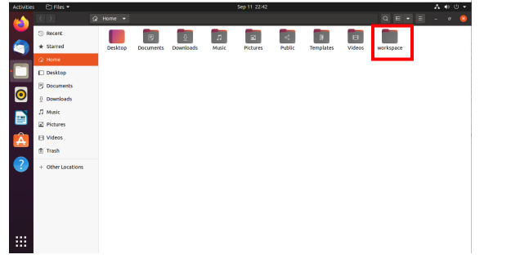

1. Go to terminal and input these commands consecutively after each command finishes executing:

cd

cd workspace

tar xjf <Name of Ns3 downloaded file name>

cd <Name of extracted Ns3>

./build.py --enable-examples --enable-tests

1. Test the NS3 build and installation success by running test.py in the ns directory using the following commands: cd ns- ./test.py

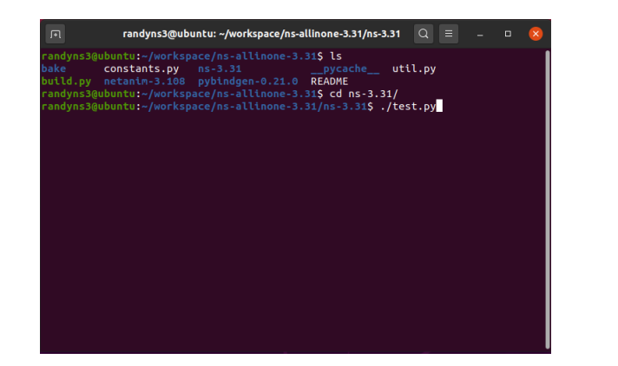

1. If all of the tests were passed, Congratulations! NS3 has now been installed successfully.

**CONCLUSION:** Thus, we have studied and successfully install NS3.

**SIGN AND REMARK**

**DATE**

| **R1**  **(3 Marks)** | **R2**  **(3 Marks)** | **R3**  **(3 Marks)** | **R4**  **(3 Mark)** | **R5**  **(3 Mark)** | **Total**  **(15 Marks)** | **Signature** |
| --- | --- | --- | --- | --- | --- | --- |
|  |  |  |  |  |  |  |

**EXPERIMENT No. 9**

| **Date of Performance :** |  |
| --- | --- |
| **Date of Submission :** |  |

AIM: Use Wire shark to understand the operation of TCP/IP layers:

* Ethernet Layer: Frame header, Frame size etc.
* Data Link Layer: MAC address, ARP (IP and MAC address binding)
* Network Layer: IP Packet (header, fragmentation), ICMP (Query and Echo)
* Transport Layer: TCP Ports, TCP handshake segments etc.

Application Layer: DHCP, FTP, HTTP header formats

# **THEORY:**

Wireshark, a network analysis tool formerly known as Ethereal, captures packets in real time and display them in human-readable format. Wireshark includes filters, color coding, and other features that let you dig deep into network traffic and inspect individual packets.

## *Capturing Packets*

After downloading and installing Wireshark, you can launch it and double-click the name of a network interface under Capture to start capturing packets on that interface. For example, if you want to capture traffic on your wireless network, click your wireless interface. You can configure advanced features by clicking Capture > Options, but this isn’t necessary for now.

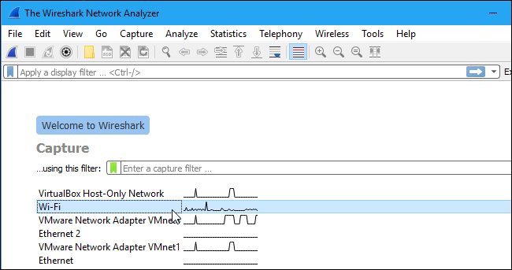

As soon as you click the interface’s name, you’ll see the packets start to appear in real time. Wireshark captures each packet sent to or from your system.

If you have promiscuous mode enabled—it’s enabled by default—you’ll also see all the other packets on the network instead of only packets addressed to your network adapter. To check if promiscuous mode is enabled, click Capture > Options and verify the “Enable promiscuous mode on all interfaces” checkbox is activated at the bottom of this window.

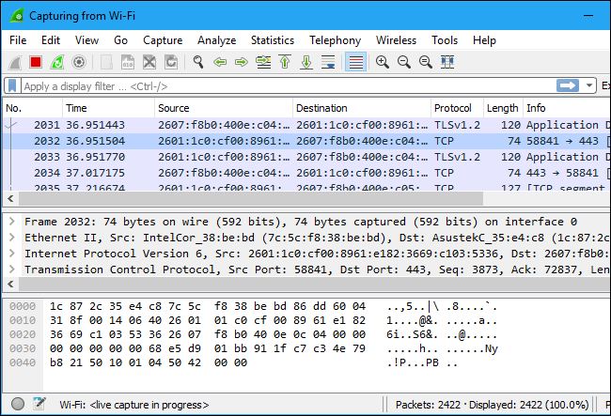

Click the red “Stop” button near the top left corner of the window when you want to stop capturing traffic.

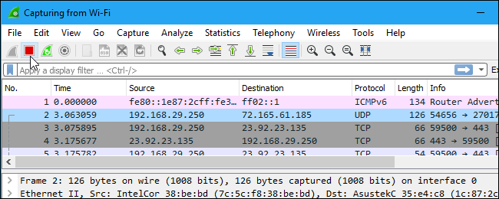

## ***Color Coding***

You’ll probably see packets highlighted in a variety of different colors. Wireshark uses colors to help you identify the types of traffic at a glance. By default, light purple is TCP traffic, light blue is UDP traffic, and black identifies packets with errors—for example, they could have been delivered out of order.

To view exactly what the color codes mean, click View > Coloring Rules. You can also customize and modify the coloring rules from here, if you like.

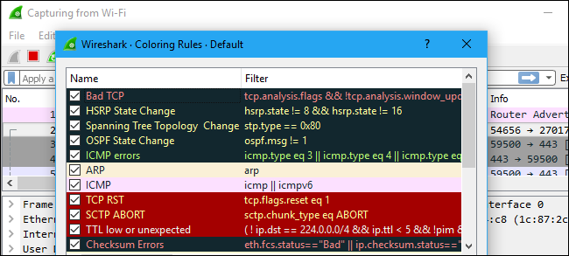

## ***Sample Captures***

If there’s nothing interesting on your own network to inspect, Wireshark’s wiki has you covered. The wiki contains a [page of sample capture files](https://wiki.wireshark.org/SampleCaptures) that you can load and inspect. Click File > Open in Wireshark and browse for your downloaded file to open one.

You can also save your own captures in Wireshark and open them later. Click File > Save to save your captured packets.

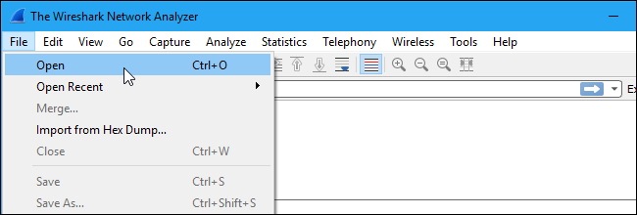

## ***Filtering Packets***

If you’re trying to inspect something specific, such as the traffic a program sends when phoning home, it helps to close down all other applications using the network so you can narrow down the traffic. Still, you’ll likely have a large amount of packets to sift through. That’s where Wireshark’s filters come in.

The most basic way to apply a filter is by typing it into the filter box at the top of the window and clicking Apply (or pressing Enter). For example, type “dns” and you’ll see only DNS packets. When you start typing, Wireshark will help you autocomplete your filter.

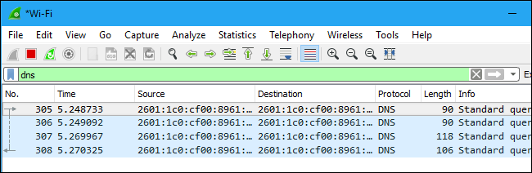

You can also click Analyze > Display Filters to choose a filter from among the default filters included in Wireshark. From here, you can add your own custom filters and save them to easily access them in the future.

For more information on Wireshark’s display filtering language, read the [Building display filter expressions](https://www.wireshark.org/docs/wsug_html_chunked/ChWorkBuildDisplayFilterSection.html) page in the official Wireshark documentation.

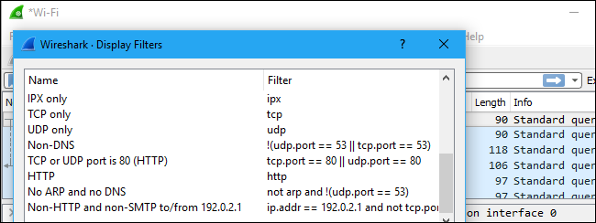

Another interesting thing you can do is right-click a packet and select Follow > TCP Stream.

You’ll see the full TCP conversation between the client and the server. You can also click other protocols in the Follow menu to see the full conversations for other protocols, if applicable.

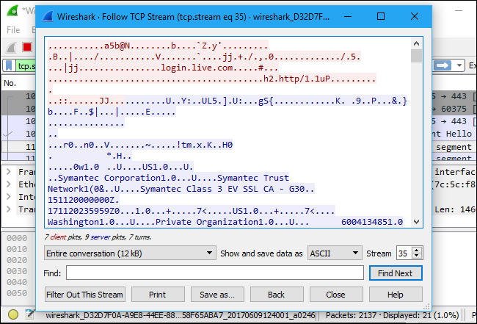

Close the window and you’ll find a filter has been applied automatically. Wireshark is showing you the packets that make up the conversation.

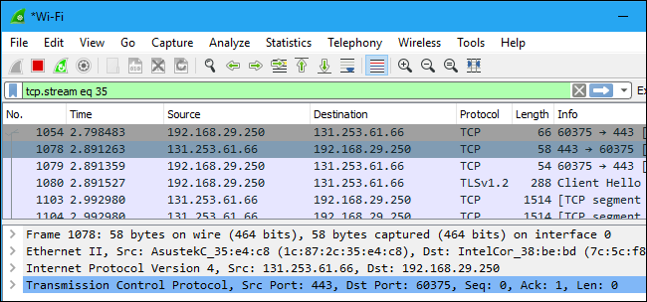

## ***Inspecting Packets***

Click a packet to select it and you can dig down to view its details.

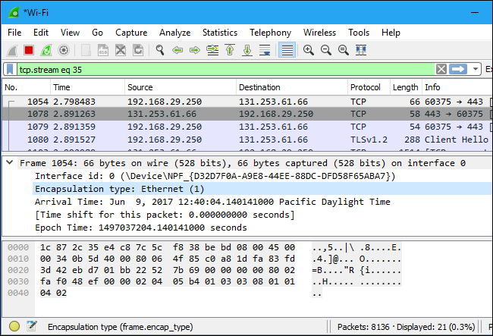

You can also create filters from here — just right-click one of the details and use the Apply as Filter submenu to create a filter based on it.

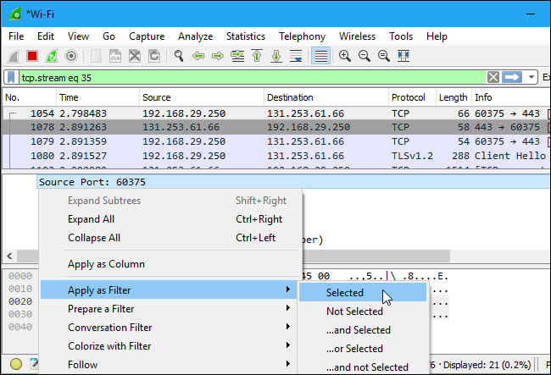

Wireshark is an extremely powerful tool, and this tutorial is just scratching the surface of what you can do with it. Professionals use it to debug network protocol implementations, examine security problems and inspect network protocol internals.

**CONCLUSION:** Thus, we have studied the working of Wire Shark.

**SIGN AND REMARK**

**DATE**

| **R1**  **(3 Marks)** | **R2**  **(3 Marks)** | **R3**  **(3 Marks)** | **R4**  **(3 Mark)** | **R5**  **(3 Mark)** | **Total**  **(15 Marks)** | **Signature** |
| --- | --- | --- | --- | --- | --- | --- |
|  |  |  |  |  |  |  |

**EXPERIMENT No. 10**

| **Date of Performance :** |  |
| --- | --- |
| **Date of Submission :** |  |

**AIM:**

1. Set up multiple IP addresses on a single LAN.
2. Using nestat and route commands of Linux, do the following:
   * View current routing table
   * Add and delete routes
   * Change default gateway

Perform packet filtering by enabling IP forwarding using IPtables in Linux.

**Theory:**

First, let us find the IP address of the network card. In my Ubuntu 15.10 server, I use only one network card.

Run the following command to find out the IP address:

sudo ip addr

**Sample output:**

1: lo: <LOOPBACK,UP,LOWER_UP> mtu 65536 qdisc noqueue state UNKNOWN group default

link/loopback 00:00:00:00:00:00 brd 00:00:00:00:00:00

inet 127.0.0.1/8 scope host lo

valid_lft forever preferred_lft forever

inet6 ::1/128 scope host

valid_lft forever preferred_lft forever

2: **enp0s3**: <BROADCAST,MULTICAST,UP,LOWER_UP> mtu 1500 qdisc pfifo_fast state UP group default qlen 1000

link/ether 08:00:27:2a:03:4b brd ff:ff:ff:ff:ff:ff

inet **192.168.1.103/24** brd 192.168.1.255 scope global enp0s3

valid_lft forever preferred_lft forever

inet6 fe80::a00:27ff:fe2a:34e/64 scope link

valid_lft forever preferred_lft forever

Or

sudo ifconfig

**Sample output:**

**enp0s3** Link encap:Ethernet HWaddr 08:00:27:2a:03:4b

inet addr:**192.168.1.103** Bcast:192.168.1.255 Mask:255.255.255.0

inet6 addr: fe80::a00:27ff:fe2a:34e/64 Scope:Link

UP BROADCAST RUNNING MULTICAST MTU:1500 Metric:1

RX packets:186 errors:0 dropped:0 overruns:0 frame:0

TX packets:70 errors:0 dropped:0 overruns:0 carrier:0

collisions:0 txqueuelen:1000

RX bytes:21872 (21.8 KB) TX bytes:9666 (9.6 KB)

lo Link encap:Local Loopback

inet addr:127.0.0.1 Mask:255.0.0.0

inet6 addr: ::1/128 Scope:Host

UP LOOPBACK RUNNING MTU:65536 Metric:1

RX packets:217 errors:0 dropped:0 overruns:0 frame:0

TX packets:217 errors:0 dropped:0 overruns:0 carrier:0

collisions:0 txqueuelen:0

RX bytes:38793 (38.7 KB) TX bytes:38793 (38.7 KB)

As you see in the above output, my network card name is **enp0s3**, and its IP address is **192.168.1.103**.

Now let us add an additional IP address, for example **192.168.1.104**, to the Interface card.

Open your Terminal and run the following command to add additional IP.

sudo ip addr add 192.168.1.104/24 dev enp0s3

Now, let us check if the IP is added using command:

sudo ip address show enp0s3

**Sample output:**

2: enp0s3: <BROADCAST,MULTICAST,UP,LOWER_UP> mtu 1500 qdisc pfifo_fast state UP group default qlen 1000

link/ether 08:00:27:2a:03:4e brd ff:ff:ff:ff:ff:ff

inet 192.168.1.103/24 brd 192.168.1.255 scope global enp0s3

valid_lft forever preferred_lft forever

inet **192.168.1.104/24** scope global secondary enp0s3

valid_lft forever preferred_lft forever

inet6 fe80::a00:27ff:fe2a:34e/64 scope link

valid_lft forever preferred_lft forever

Similarly, you can add as many IP addresses as you want.

Let us ping the IP address to verify it.

sudo ping 192.168.1.104

**Sample output:**

PING 192.168.1.104 (192.168.1.104) 56(84) bytes of data.

64 bytes from 192.168.1.104: icmp_seq=1 ttl=64 time=0.901 ms

64 bytes from 192.168.1.104: icmp_seq=2 ttl=64 time=0.571 ms

64 bytes from 192.168.1.104: icmp_seq=3 ttl=64 time=0.521 ms

64 bytes from 192.168.1.104: icmp_seq=4 ttl=64 time=0.524 ms

### **To check the routing table**

**Command*:****nestat -rn*

$ netstat -rn

Kernel IP routing table

Destination Gateway Genmask Flags MSS Window irtt Iface

0.0.0.0 192.168.0.1 0.0.0.0 UG 0 0 0 wlan0

192.168.0.0 0.0.0.0 255.255.255.0 U 0 0 0 wlan0

### **Adding route**

sudo route add -net 192.168.3.0 gw 192.168.1.1 netmask 255.255.255.0 dev eth0

### **Deleting route**

sudo route del -net 192.168.3.0 gw 192.168.1.1 netmask 255.255.255.0 dev eth0

### **A quick way to add default route**

route add default gw 192.168.1.1

### **A  quick way to delete defualt route**

route del default gw 192.168.1.1

**CONCLUSION:** Thus, we have studied and successfully add the multiple IP address and also perform actions in Linux

**SIGN AND REMARK**

**DATE**

| **R1**  **(3 Marks)** | **R2**  **(3 Marks)** | **R3**  **(3 Marks)** | **R4**  **(3 Mark)** | **R5**  **(3 Mark)** | **Total**  **(15 Marks)** | **Signature** |
| --- | --- | --- | --- | --- | --- | --- |
|  |  |  |  |  |  |  |